PROJECT Console Programming with Python - A Game of Chances

Objective To use Python to demonstrate a game - based Console Application.

PROJECT DESCRIPTION

Create and code a Python application for the following scenario:

a GUESSING game

Follow the steps below to design and create this game application.

Wishing you a successful gameplay!

Information About This Project

The initial game screen consists of three sequential guessing segments.
___________________________________________________________________

[ Guess: An Alphabetic Character ]

Standard English alphabet

A | B | C | D | E | F | G | H | I | J | K | L | M | N | O | P | Q | R | S | T | U | V | W | X | Y | Z
K | L | M | N | O | P | Q | R | S | T | U | V | W | X | Y | Z | A | B | C | D | E | F | G | H | I | J
___________________________________________________________________

[ Guess: Flip a Coin ]

Standard U.S. Coin

HEADS | TAILS
___________________________________________________________________

[ Guess: A Single Digit ]

Standard Base Ten Non - Zero Digits

1 | 2 | 3 | 4 | 5 | 6 | 7 | 8 | 9
___________________________________________________________________

[ The Sample Game Play ]

First Action: The Player begins the game and enters a letter → G

Second Action: The Player then flips a coin and enters a side → 1 ( for TAILS )

Third Action: The Player then chooses a digit to enter → 7 ( five ATTEMPTS )

Steps to Complete This Project

STEP 1 Open a Web Browser

Launch a Web Browser on your computer, such as Microsoft Edge, MAC Safari, Google Chrome, Firefox, Mozilla, etc.

STEP 2 Travel to a Web Link

Navigate to the Web site that is given by the link below.

https://www.programiz.com/python-programming/online-compiler/

STEP 3 Observe the Initial Code Statements

At the above Web site, view the given test code that is provided.
_________________________________________________________________

# Python compiler (interpreter) to run Python online.
# Write Python code in this online editor and run it.

print("Hello World!")
_________________________________________________________________

STEP 4 Copy the Program Code

Highlight and delete all the code statements that are initially provided at the above Web site.

Then, copy all the program code statements that are given in Figure 1 , which follows.

Be sure to copy just the code statements and to include all the statements.

Figure 1 Program Code: The Guessing Game

# Guessing Game using Python

import random

print ("Welcome to the Guessing Game")
print ("----------------------------")

print ("first: enter a LETTER (between A and Z):")
myInput = input().upper()
guessChar = myInput[0]
# randint function generate an ASCII number from 65 to 90
letter = random.randint(65, 90)
chk = guessChar == chr(letter)
if (chk == True) :
print ("Good guess!!")
else :
print ("your letter:", guessChar, "; their letter:", chr(letter))
print ()

# enter a 0 for HEADS and a 1 for TAILS
print("Guess a COIN flip (HEADS or TAILS):")
print("enter a 0 for HEADS and a 1 for TAILS")
guessCoin = int(input())

# randint function generate a number from 0 to 1
coin = random.randint(0, 1)
if (coin == 0 and guessCoin == 0) :
flip = "HEADS"
print ("Good guess!!")
print ("your coin:", flip, "their coin:", flip)
else :
flip = "TAILS"
print ("Maybe next time!")
print ("your coin:", flip, "their coin: HEADS")
print ()

# randint function generate a number from 1 to 9
number = random.randint(1, 9)

# number of chances to be given
chances = 0
chk = False
print ("Now you have 5 chances to guess a number!")
print ()

# while loop to loop through the number of chances
while chances < 5 :
# increase the value of the chance variable by 1
chances += 1

# enter a number between 1 to 9
print("Guess a NUMBER (between 1 and 9):")
guessNum = int(input())

# compare the user entered number
# with the number to be guessed
if (guessNum == number) :
# if number entered by user is same as the number
# generated by the randint function
print("Congratulations! YOU are a WINNER!!!")
break
# check if the user entered a number smaller than
# the generated number
elif (guessNum < number) :
print("Too Low: Guess a number higher than", guessNum)

# user entered number is greater than the generated number
else :
print("Too High: Guess a number lower than", guessNum)

# check whether the user guessed the correct number
if (not chances < 5) :
print("Sorry, YOU LOSE!!! The number is", number)

STEP 5 Run the Starter Code Program

After you have copied the program code into that online compiler, click the
[ Run ] button there to execute the program.

An output screen such as shown below will then appear.

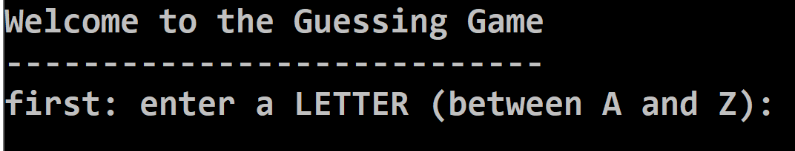

A sample screen snapshot of the game play is given below.

STEP 6 Play the Game

After you compile your program, run the program with multiple executions using each of these three scenarios.

A sample run is shown in Figure 2 , which follows.
_________________________________________________________________
Scenario One

player correctly guesses a Letter, a Coin Flip, a Single Digit

Scenario Two

player correctly guesses at least one of a Letter, a Coin Flip, a Single Digit

Scenario Three

player incorrectly guesses each of a Letter, a Coin Flip, a Single Digit
_________________________________________________________________
_______________________________________________________________________________

Figure 2 Program Output: The Guessing Game

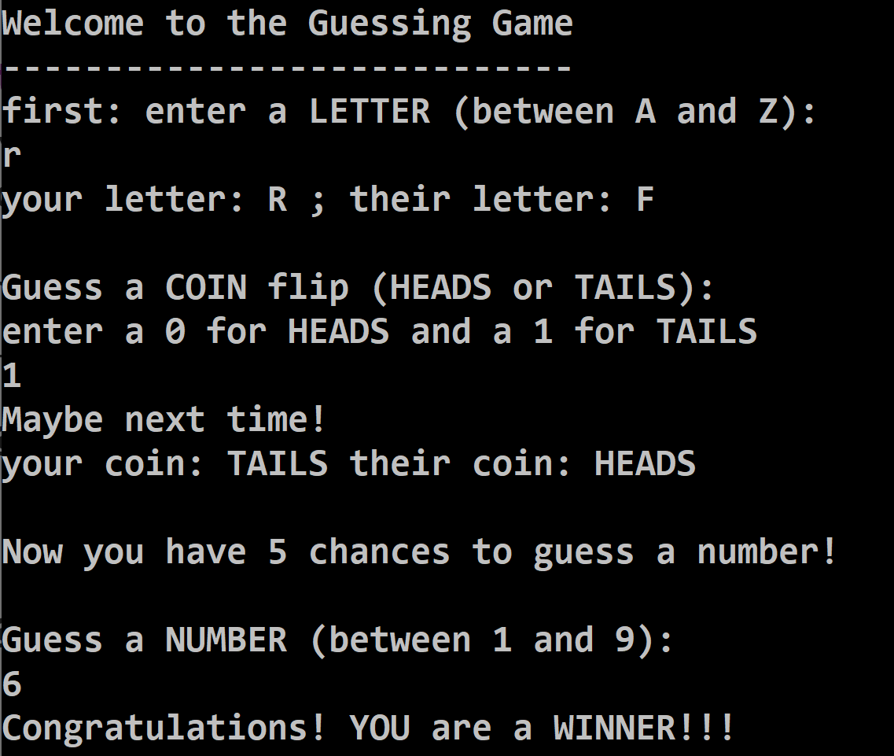

STEP 8 For Further Exploration

For further discussion, here are some intriguing questions for pondering, which concern this application.

(1) Explain how you would supplement this application such that the game player will also select a single card from a well - shuffled deck of 52 playing cards.

(2) Explain how random numbers are used in this game application?

(3) Do our program code statements for this application include any Exception Handling, e.g. a 3 is entered when we ask for a 0 or a 1 ?

(4) Explain how you would supplement this application such that the game player will also select a number when a six - sided die is tossed.

